CENWP-OD 21 April 2010

MEMORANDUM FOR THE RECORD

Subject: FINAL minutes for the 21 April 2010 FPOM conference call.

The meeting was held via conference call. In attendance:
Bettin | Scott | BPA | 503-230-4573 | swbettin@bpa.gov
Byrne | Brandon | Smith Root
Crump | Rick | Smith Root
Fredricks | Gary | NOAA | 503-231-6855 | Gary.fredricks@noaa.gov
Hausmann | Ben | USACE-BON | 541-374-4598 | Ben.j.hausmann@usace.army.mil
Klatte | Bern | USACE-NWP | 503-808-4318 | Bernard.a.klatte@usace.army.mil
Kruger | Rick | ODFW | 971-673-6012 | Rick.kruger@coho2.dfw.state.or.us
Lorz | Tom | CRITFC | 503-238-3574 | lort@critfc.org
Mackey | Tammy | USACE-NWP | 541-374-4552 | Tammy.m.mackey@usace.army.mil
Mesa | Matt | USGS
Rerecich | Jon | USACE-BON | 541-374-7984 | Jonathan.g.rerecich@usace.army.mil
Scott | Shane | S. Scott and Associates | 360-576-4830 | Sscott06@earthlink.net
Sweet | Jason | BPA | 503-230-3349 | jcsweet@bpa.gov
Volkman | Eric | BPA | 503-230-3182 | etvolkman@bpa.gov
Wills | David | USFWS | 360-604-2500 | David_wills@fws.gov

- Finalized results from this meeting.
  - Wills, Fredricks, Smith Root, Mesa, Kruger, Mackey, Klatte will meet at the Washington Shore VOB at 0900 to view the array.
  - Smith Root can go forward with testing on 22 April while biologists are observing fish behavior. If there is no reaction, then testing can move forward. Smith Root will wedge the frame as soon as possible. The wedging shall occur between 0800 until 1000 for a couple of days.

- The following documents were provided or discussed. Documents may be found at http://www.nwd-wc.usace.army.mil/tmt/documents/FPOM/2009/
  - 100421 Official Coordination form- BON UMT trapped juveniles.

- Fredricks asked how comfortable Mesa was with the DIDSON images. Mesa said he would rate the images a 6 on a scale of 1 – 10. On 20 April they were able to see about a meter into the array and could see the fish, especially the tails.

- Smith Root personnel took another picture of the window and said there were fewer fish in the window. Rerecich asked when they were at the UMT. Smith Root said they were in the UMT about 0900. Rerecich said he was there at 1130 and saw 175.

- Smith Root explained the UMT wall isn’t straight so there is about a 1 ½ inch gap so fish could get in and if they could get in, they could get out. S. Scott said the water is about even with the top of the array. Perhaps the fish got up and over.
  - Fredricks asked if the array could be pulled out and put back in. Smith Root said it could be pulled but it would be a major exercise. The array couldn’t go back in with the UMT watered up. Fredricks asked if the water could be stopped. Hausmann said yes, the bulkhead could be installed but there would be no guarantee there were no fish underneath.
  - Smith Root suggested the fish back there are not an issue since the field is insulated.

- Fredricks asked if the panels could be removed. Smith Root said it could be done. Mackey asked if there are areas where the array is tight against the wall. Smith Root said there are areas such as that. Mackey suggested there may be pockets where fish would have no egress since they are not programmed to swim against flow.

- Bettin asked if it would be possible to turn the array on until FPOM can come to a decision.

- Wills expressed disappointment at the attitude of just leaving the fish there. Kruger agreed. Fredricks said that is why he wants to hear what can be done.

- Several ideas were discussed such as getting divers in there to pull panels, cut slots in panels, pull the area and reinstall it, etc.
  - Most of the ideas required reduced flow in the UMT.
  - Lorz had to get off the phone but he indicated he was willing to allow for cutting the holes but once lamprey come, he isn’t on board with this. Lamprey show up around June.
  - Mackey reminded people that a dive contract takes at least two weeks so is there enough time to get the divers in there and still get the testing completed by the end of May.

- Loosening the turnbuckles might allow a big enough gap for fish to move through. Cross members would need to be shortened.
  - Kruger asked if there was a floor and if it was possible fish were under the array as well. Smith Root explained the floor is open to the walls. Kruger asked if he could come out to see the array on 22 April. Wills, Kruger, S. Scott and Fredricks will meet at BON at 0900.
  - Bettin asked if the array could be turned on and testing begin tomorrow. Fredricks said there must be someone there to watch how the fish react. Wills said only if Smith Root could be 100% sure there is no electric field behind the array.
  - Fredricks asked how long it would take to move the walls in a little. S. Scott said it could be done tomorrow. Fredricks said that would be good so the testing could occur when fewer Spring Creek fish are trapped. Wedges would be used to open the frame. The work would be completed from the walkway and +90’ deck, no over-water work.

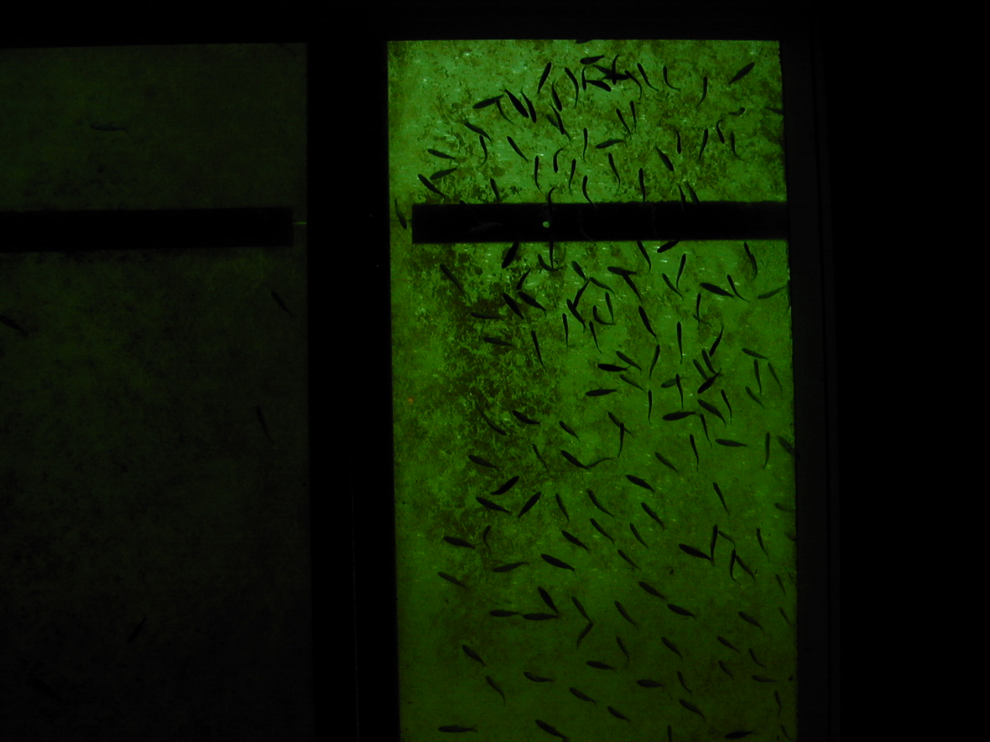
Taken 19 April. BON UMT count window.

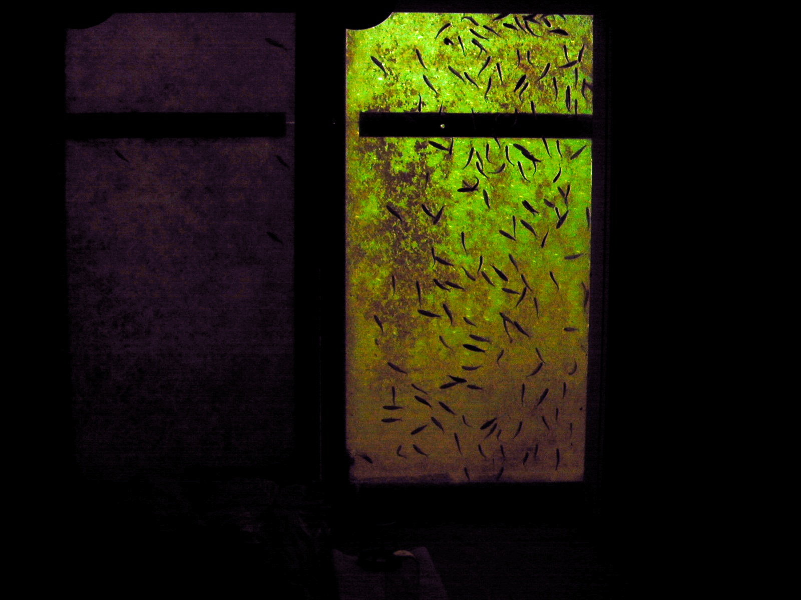
Taken 20 April 2010. BON UMT count window.

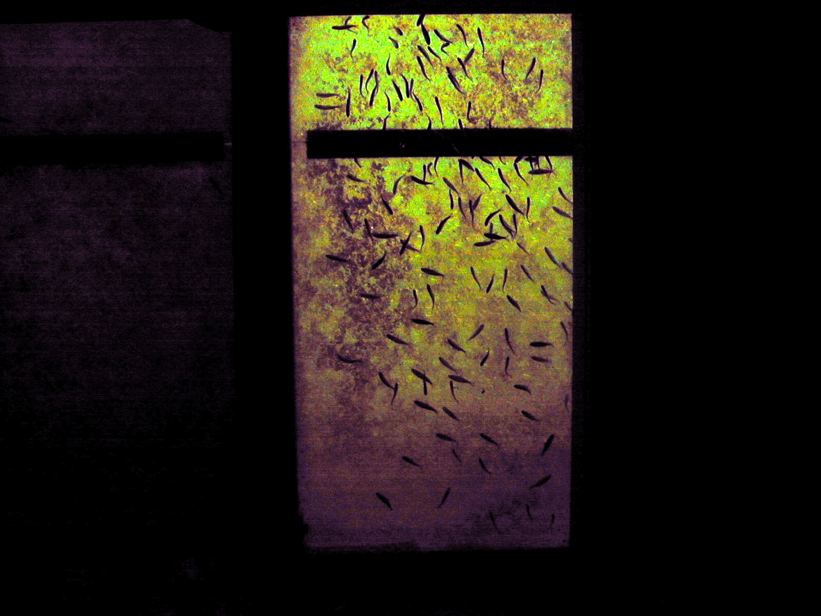
Taken 21 April 2010. BON UMT count window.

